**Willows Patient Participation Group**

**Mpox**

If you have been fortunate enough to travel abroad recently, you will have seen warning signs for Mpox. The World health Organisation has declared the mpox outbreaks in parts of Africa as a public health emergency of international concern. Mpox is caused by a virus in the same family as smallpox but is usually less harmful. Initial symptoms include fever, headaches, swellings, back pain and aching muscles. Once the fever breaks, a rash can develop. Check the NHS website for more information.

**Vaccinations**

It’s that time of year again for flu and Covid jabs if you are eligible. Look out for vaccination sessions at the Willows including a weekend session. Flu jabs are available now. Pneumonia, Respiratory Syncytial Virus (RSV) and shingles jabs are also available to those who qualify and you should have already been contacted by The Willows to come in and have yours. If you couldn’t make it or forgot and now wish to have these jabs, phone the Willows for an appointment.

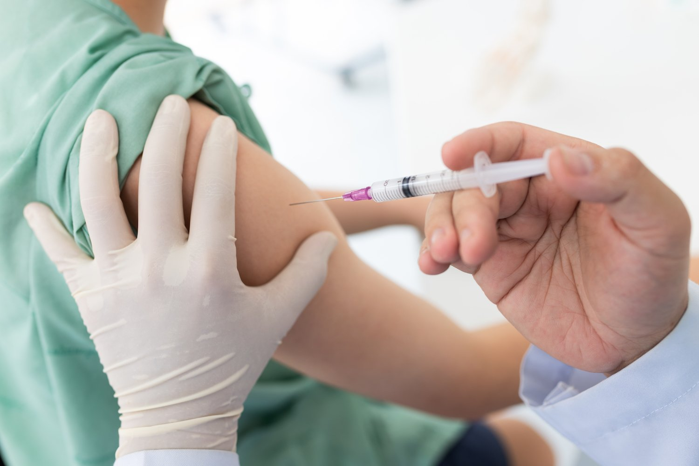

**Blood test results**

Have you used the EMIS Patient Access App or web link yet? You can use it for example to see any blood test results. It saves you phoning the surgery for your results and helps you understand the breakdown of the various blood tests undertaken. It’s an effective way to track your results if you have regular blood tests.

**Blood Pressure Checks**

Did you know that in England alone, there are 8 million people who have high blood pressure, also known as hypertension. Blood pressure checks can be carried out at home, at a pharmacy, at an NHS Health Check appointment or at a doctor’s surgery. Blood pressure is the term used to describe the strength with which your blood pushes on the sides of your arteries as its pumped around your body. It is important that your blood pressure is treated if it is high and this can be for example by lifestyle changes or medication. It is important to establish the cause of high blood pressure as uncontrolled hypertension can lead to other health concerns. Blood pressure monitors are relatively cheap to purchase and enable you to keep track of your readings in your home environment, something that is particularly important if you suffer from white coat hypertension.

 



This group has recently refreshed its terms of reference and is seeking to recruit new members who are interested in healthcare matters. The group works with the team at The Willows sharing feedback and helping to develop improved services for patients. The Group doesn’t deal with individual complaints as there are other channels for this but if you want to know a bit more about how the practice operates and maybe help out for example when community health events are being run, why not join us?

We meet for about 1.5 hours every 3 months and are looking to attract members that represent the diverse community that is Hainault. Ask at reception for more details.



**Newsletter suggestions**

If you have any suggestions for items to be included in this newsletter or if you want to be involved in producing the newsletter, please ask at reception and the staff will let the patients group know.

**Queen’s Hospital, Romford**.

Parking - Readers will be pleased to learn that works to the multi storey car park at Queen’s Hospital have now been completed.

Ambulance Handovers – By working with the London Ambulance Service, the number of one hour plus ambulance handovers has dropped from 38% to less than 1% over the last year,

If you are interested in other developments at Queens and King George’s Hospital, check out the Chief Executive Updates on: www.bhrhospitals.nhs.net

**Enhanced Access Hub**

Did you know that 7 GP practices benefit from an enhanced access hub at the Fencepiece Medical Centre along Fencepiece Road? The purpose of the hub is to ensure that people who urgently need to be seen by a GP are able to do so.

The Hub can offer appointments if all the slots at The Willows are allocated. The Hub operates between 6.30pm and 9.30 pm weekdays and between 8.30am and 5pm on Saturdays for pre bookable appointments. Both The Willows and NHS 111 can book you into the Hub or you can call the service directly on 0204 506 8824 between 5pm-8pm weekdays and between 8.30am and 5pm on Saturdays. The GPs at the Hub have access to your medical records so it’s no different to seeing a GP at The Willows. The Hub offers a range of services and for people who work during the day, an evening appt for say a smear test or immunisations for your child might be useful.

**The Willows Patient Participation Group**

**Newsletter**

**October 2024**